ELECTRICAL CIRCUITS
What is a circuit?
It is a closed pathway in which electrons flow. It contains a power supply, current and other components.
Components:
-voltage (volts - V): it is the electrical charge of the power supply
-current (amperes - I): it’s the flow of electrons in a circuit. From negative to positive
-resistance (ohms ò ohmios - Ω): it is the component that opposes to the flow of current
ºequivalent resistance in series: sum of every resistance

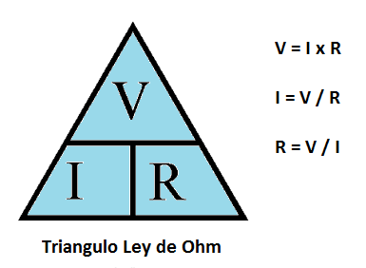

Types of circuits:
-series: it’s a closed pathway in which the current flows through all the components without branching.
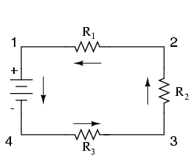
-parallel: it’s a closed pathway in which the current flows through some components doing branching
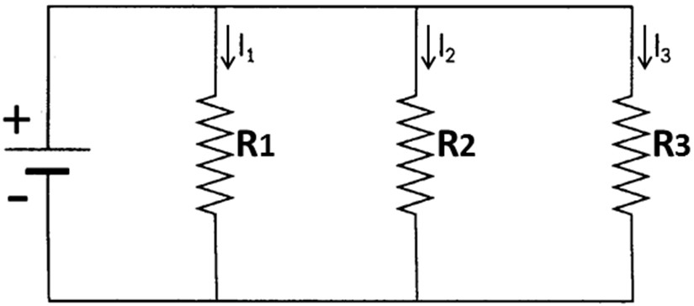
-mixed: it’s a combination of parallel and series
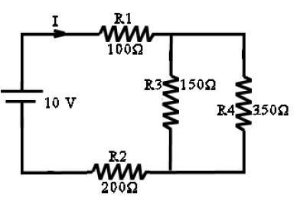
Reduction of circuits
It’s to take the circuit to its minimum expression with only one resistor
*Lo mejor es llevar cada circuito a serie.
*amperios unidad de la corriente
-Series:
1kΩ=1000Ω
0.1kΩ=100Ω
Req: Resistencia equivalente
-Parallel:
*suma de todas las Corrientes es equivalente a la corriente total
R₁xR₂/R₁+R₂
Fórmula para 3 o más resistencias:
1/1/R₁+1/R₂+1/R₃+1/R₄

